# Steps to connect P2S VPN

## Install Azure VPN Client

Software can be Downloaded from below URL

<https://www.microsoft.com/en-us/p/azure-vpn-client/9np355qt2sqb#activetab=pivot:overviewtab>

## Import XML File

AO Team will share *.XML file

## To import a client profile

1. On the page, select **Import**.

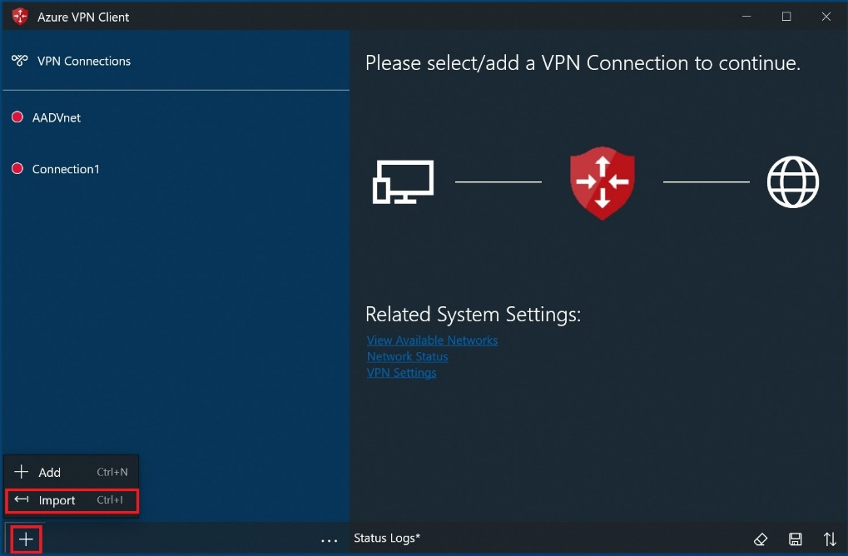

1. Browse to the profile xml file and select it. With the file selected, select **Open**.

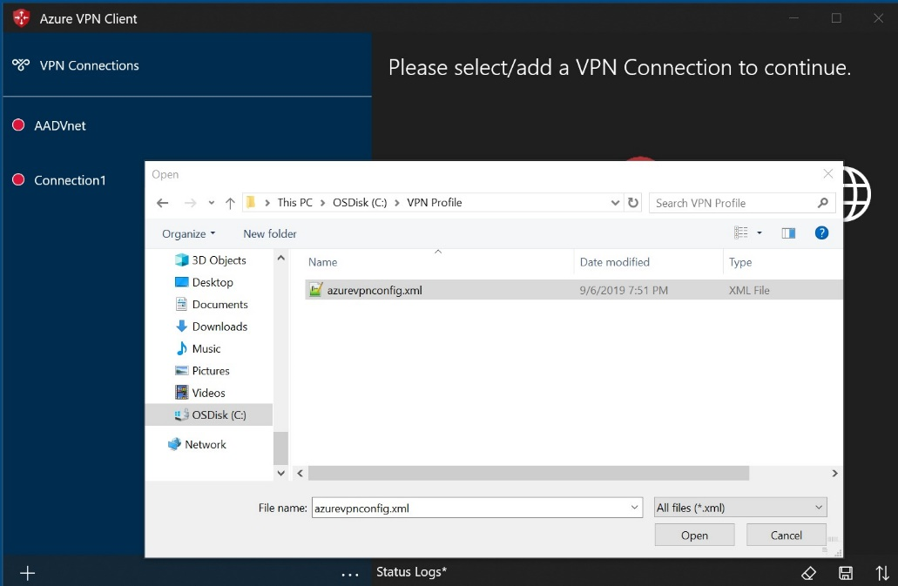

1. Specify the name of the profile and select **Save**.

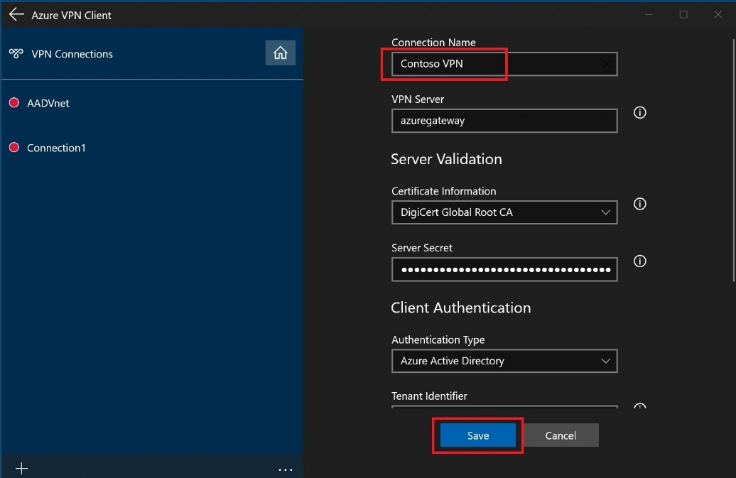

1. Select **Connect** to connect to the VPN.

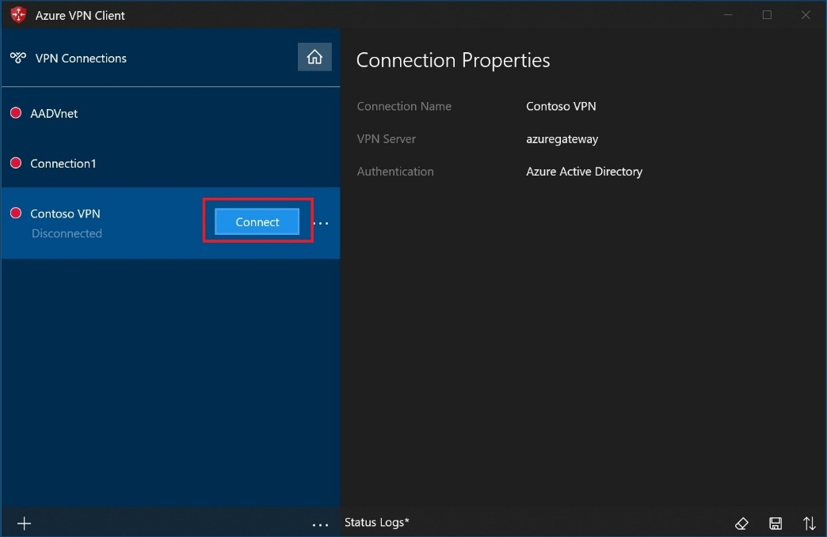

1. Prompt to enter Credential (login with *.eluxmkt.com account)

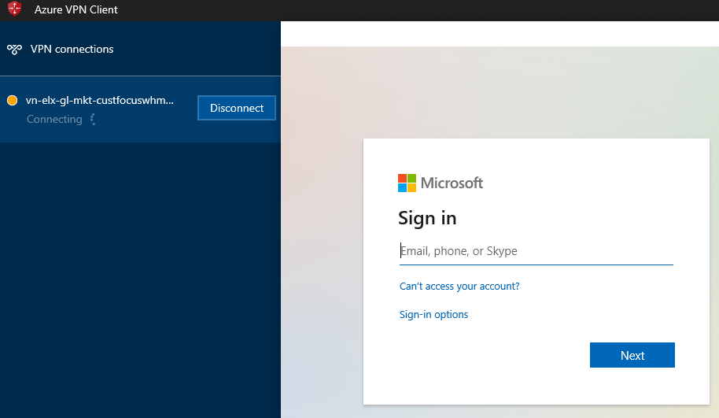

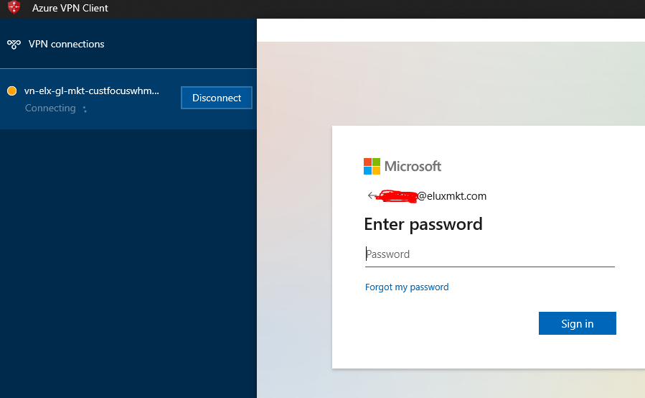

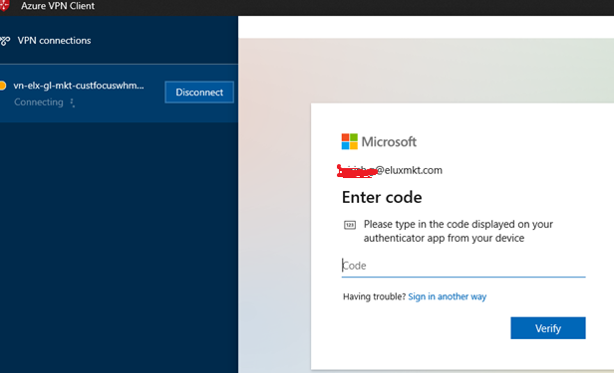

1. Uncheck **allow my org to manage my device** and select – **No, sign in to this app only**

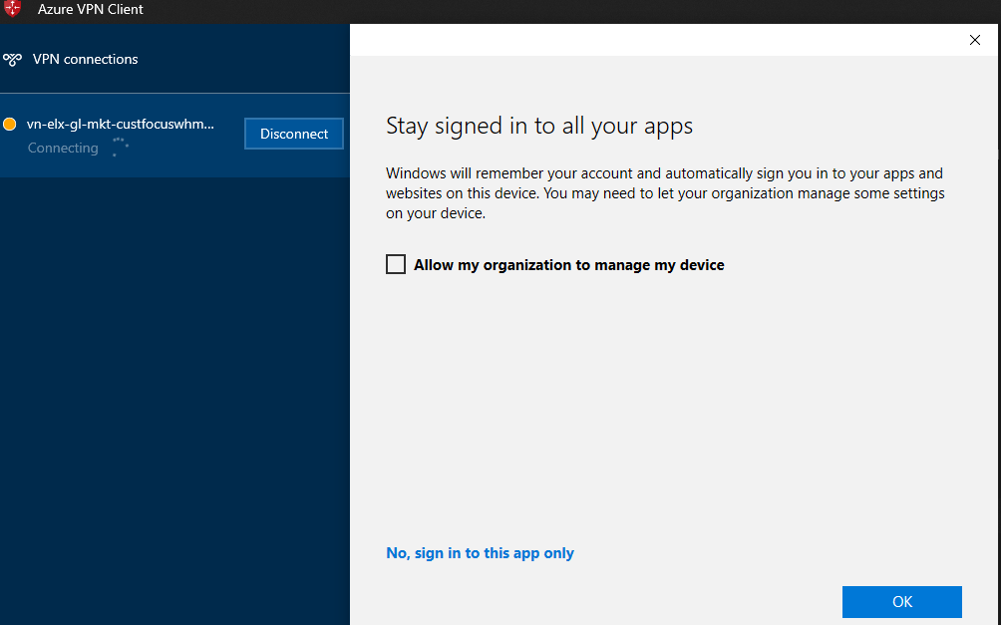

1. Azure P2S VPN is connected.

